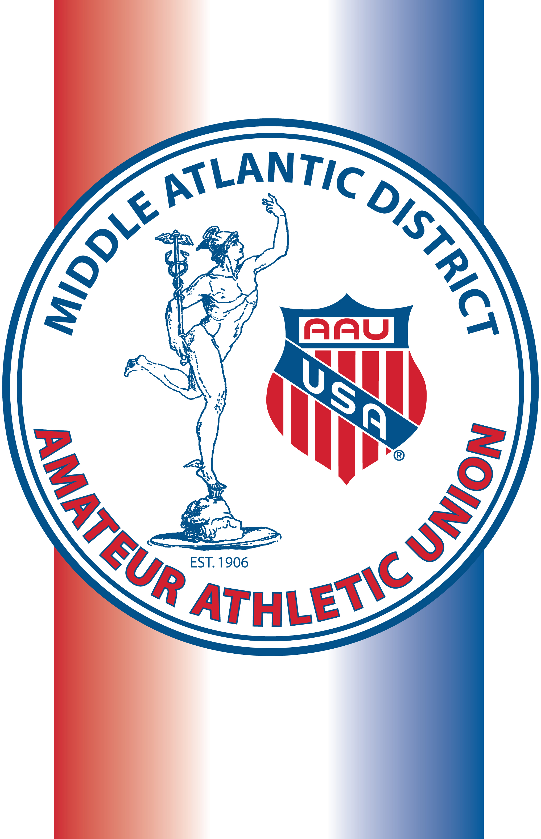**Junior/Senior Middle Atlantic All Academic Award**

**Requirements:**

• Participated in Middle Atlantic District or National AAU event in 2024/2025

• Must be a Middle Atlantic District AAU Member

• Minimum GPA 3.8 on a 4.0 scale, other grade scales, as well as weighted courses will be calculated

(if extenuating circumstances, explain)

• A copy of the **final school year report card with the** **school’s name on it must be attached**

• Senior Award: grades 9-12/ Junior Award: grades 5-8

• Form filled in and **postmarked by July 10, 2025**

Name: ______________________________________________________________________________________________________

AAU Membership number: __________________________________Year of Graduation from HS: 20_________

Address: ____________________________________________________________________________________________________

City_____________________________________State________ZIP___________ Phone: (__­­____)______________________

E-mail:________________________________________ Sport: ____________________________________________________

Club (if applicable): ________________________________________________________________________________________

**2024/25 Middle Atlantic District Championship/Qualifier participated in:** ____________________

Location: _______________________________________Date of District Qualifier: ________________________________

Your Academic School: ___________________________________________________________________________________

School Address: ______________________________________City: ______________ State: ________ Zip: ___________

**List any Academic Achievements past two years:** *(feel free to use the back)*

**List any Sports Achievements past two years:** *(feel free to use the back)*

AAU Coach Signature: _____________________________________________________________________________________

Parent Signature: __________________________________________________________________________________________

**Postmark by July 10, 2025**



**Send to: Middle Atlantic AAU, PO Box 631, Ardmore, PA 19003**

Award Certificate will be sent by August 31, 2025

Award Winners will be posted on madaau.org

Applicants will be informed of final decision